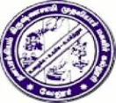
D.K.M. COLLEGE FOR WOMEN (AUTONOMOUS)
Affiliated to Thiruvalluvar University
Sainathapuram, Vellore – 632 001
Website: www.dkmcollege.ac.in
-------------------------------------------------------------------------------------------------------------------------
SELF STUDY REPORT - SUPPORTING DOCUMENTS

QUESTION 7.1.1 Describe the Institutional efforts/initiatives in providing an inclusive environment i.e., tolerance and harmony towards cultural, regional, linguistic, communal socioeconomic and other diversities.
- Fine arts activities

