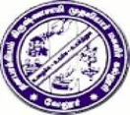
D.K.M. COLLEGE FOR WOMEN (AUTONOMOUS)
Affiliated to Thiruvalluvar University
Sainathapuram, Vellore – 632 001
Website: www.dkmcollege.ac.in
-------------------------------------------------------------------------------------------------------------------------
SELF STUDY REPORT - SUPPORTING DOCUMENTS
QUESTION 7.1.11. Institution celebrates / organizes national and international commemorative days, events and festivals

COMMEMORATIVE%20DAYS%20VIDEO

